Write an efficient algorithm that searches for a value target in an m x n integer matrix matrix. This matrix has the following properties:

* Integers in each row are sorted in ascending from left to right.
* Integers in each column are sorted in ascending from top to bottom.

**Example 1:**

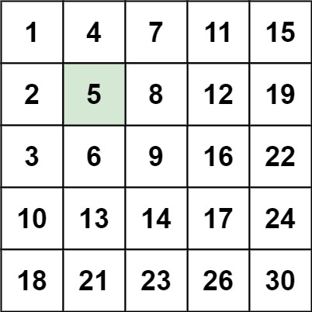

Input: matrix = [[1,4,7,11,15],[2,5,8,12,19],[3,6,9,16,22],[10,13,14,17,24],[18,21,23,26,30]], target = 5  
Output: true

**Example 2:**

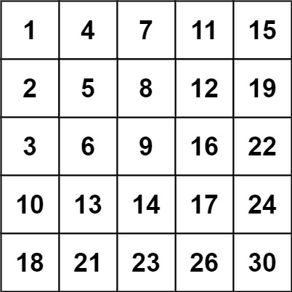

Input: matrix = [[1,4,7,11,15],[2,5,8,12,19],[3,6,9,16,22],[10,13,14,17,24],[18,21,23,26,30]], target = 20  
Output: false

**Constraints:**

* m == matrix.length
* n == matrix[i].length
* 1 <= n, m <= 300
* -109 <= matrix[i][j] <= 109
* All the integers in each row are **sorted** in ascending order.
* All the integers in each column are **sorted** in ascending order.
* -109 <= target <= 109